Reflection Activity 1
Monday, 10 March 2014
9:03 AM

We are studying perspectives of youth. So, let's ensure we hear from you… Watch, listen to or read the stimulus texts then for 5 minutes - write a response to it using the question provided as a guide.

It is important you establish an opinion and a voice in relation to issues around the world.

What is YOUR perspective?

What is your personal response to the following documentary trailer?

As a teenager, do you feel that young people have a good understanding of how women are treated differently around the world?

Ensure your response is appropriate and meaningful.

Write for 5 minutes.

Be prepared to share your thoughts in the class discussion to follow.

http://www.youtube.com/watch?v=KaR-UcCpZfA - I Am a Girl Trailer

Reflection Activity 2
Wednesday, 10 April 2013
10:33 AM

We are studying perspectives of youth. So, let's ensure we hear from you… Watch, listen to or read the stimulus texts then for 5 minutes - write a response to it using the question provided as a guide.

It is important you establish an opinion and a voice in relation to issues around the world.

What is YOUR perspective?

What is your personal response to the following images? What do you think these images say about the world around us?

Ensure your response is appropriate and meaningful.

Write for 5 minutes.

Be prepared to share your thoughts in the class discussion to follow.

Image A

Image B

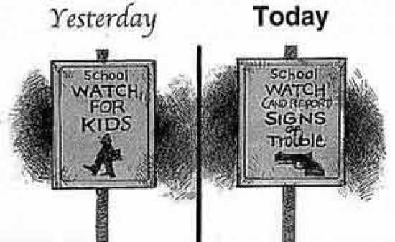

Social Justice in Discussion

Discuss the following statement.

Toy guns or no toy guns?

Reflection Activity 3
Tuesday, 11 March 2014
12:34 PM

We are studying perspectives of youth. So, let's ensure we hear from you… Watch, listen to or read the stimulus texts then for 5 minutes - write a response to it using the question provided as a guide.

It is important you establish an opinion and a voice in relation to issues around the world.

What is YOUR perspective?

What is your personal response to the following images?

How does this text aim to change society's views about disabilities? Is it really possible to change our minds about issues like this?

Ensure your response is appropriate and meaningful.

Write for 5 minutes.

Be prepared to share your thoughts in the class discussion to follow.

"Because who is perfect? Get closer." the campaign by Swiss advocacy group Pro Infirmis is designed to provoke reflection on the acceptance of people with disabilities.

http://www.nxfm.com.au/scoopla/trending-now/blog/2014/3/can-this-video-change-the-way-people-see-disability-forever-/

Reflection Activity 4
Tuesday, 11 March 2014
12:34 PM

We are studying perspectives of youth. So, let's ensure we hear from you… Watch, listen to or read the stimulus texts then for 5 minutes - write a response to it using the question provided as a guide.

It is important you establish an opinion and a voice in relation to issues around the world.

What is YOUR perspective?

What is your personal response to the following image? How does this text make you feel about a) the young boys in the image and b) the treatment of women in some countries.

Ensure your response is appropriate and meaningful.

Write for 5 minutes.

Be prepared to share your thoughts in the class discussion to follow.

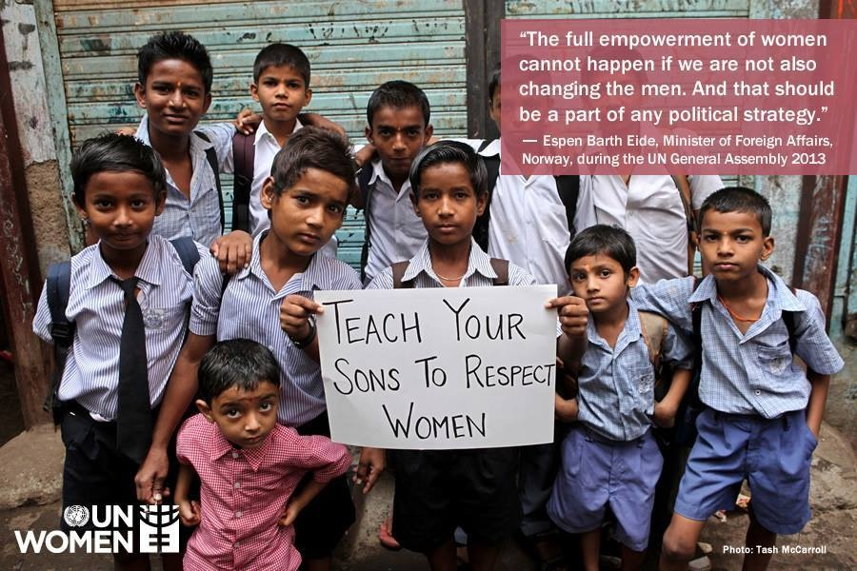

Reflection Activity 5
Saturday, 22 March 2014
8:16 PM

We are studying perspectives of youth. So, let's ensure we hear from you… Watch, listen to or read the stimulus texts then for 5 minutes - write a response to it using the question provided as a guide.

It is important you establish an opinion and a voice in relation to issues around the world.

What is YOUR perspective?

What is your personal response to the following blog post? How does this text aim to highlight how different cultures are regarded in Australian society?

Ensure your response is appropriate and meaningful.

Write for 5 minutes.

Be prepared to share your thoughts in the class discussion to follow.

http://www.mamamia.com.au/social/ban-hijab-girls-soccer-team

Reflection Activity 6
Monday, 31 March 2014
8:21 PM

We are studying perspectives of youth. So, let's ensure we hear from you… Watch, listen to or read the stimulus texts then for 5 minutes - write a response to it using the question provided as a guide.

It is important you establish an opinion and a voice in relation to issues around the world.

What is YOUR perspective?

What is your personal response to the following commercial? What was the purpose of the commercial? Do you think it was effective? Why or why not?

Ensure your response is appropriate and meaningful.

Write for 5 minutes.

Be prepared to share your thoughts in the class discussion to follow.

http://www.mamamia.com.au/rogue/snickers-ad/

Reflection Activity 7
Wednesday, 10 April 2013
10:33 AM

We are studying perspectives of youth. So, let's ensure we hear from you… Watch, listen to or read the stimulus texts provided then for 5 minutes - write a response to it using the question provided as a guide.

It is important you establish an opinion and a voice in relation to issues around the world.

What is YOUR perspective?

What is your personal response to the following images? What do you think these images say about the world around us?

Ensure your response is appropriate and meaningful.

Write for 5 minutes.

Be prepared to share your thoughts in the class discussion to follow.

Image A

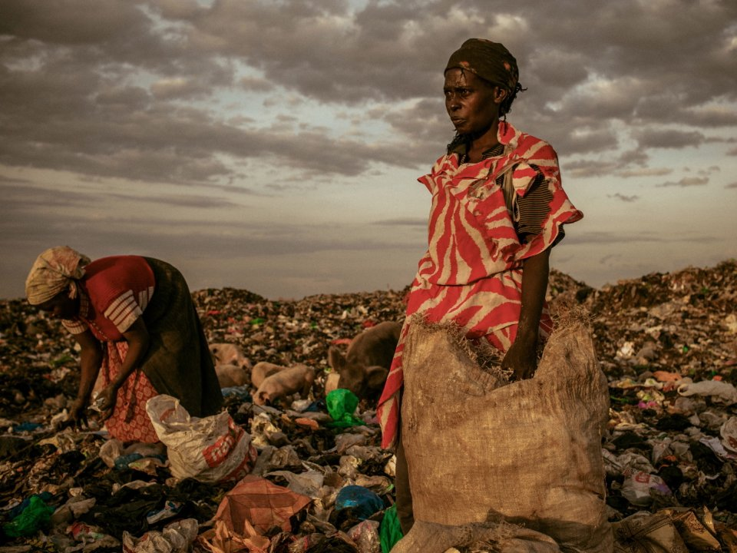

Image B

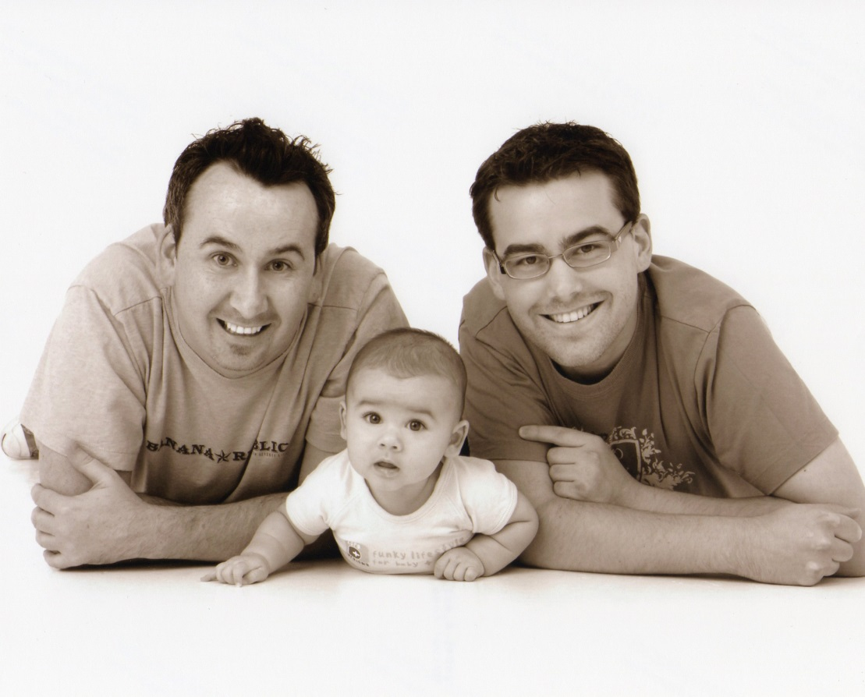

Social Justice in Discussion

Discuss the following statement.

Toy guns or no toy guns?

Reflection Activity 8
Monday, 10 March 2014
9:03 AM

We are studying perspectives of youth. So, let's ensure we hear from you… Watch, listen to or read the stimulus texts then for 5 minutes - write a response to it using the question provided as a guide.

It is important you establish an opinion and a voice in relation to issues around the world.

What is YOUR perspective?

What is your personal response to the following blog post? How do you feel about the way the girls have been treated?

Ensure your response is appropriate and meaningful.

Write for 5 minutes.

Be prepared to share your thoughts in the class discussion to follow.

http://www.mamamia.com.au/parenting/kim-kelley-wagner-photos/ - Photos of Adopted Children - treated by society

Reflection Activity 9
Thursday, 24 April 2014
5:20 PM

We are studying perspectives of youth. So, let's ensure we hear from you… Watch, listen to or read the stimulus texts then for 5 minutes - write a response to it using the question provided as a guide.

It is important you establish an opinion and a voice in relation to issues around the world.

What is YOUR perspective?

What is your personal response to the following campaign image? What issue is it trying to highlight? Is it effective?

Ensure your response is appropriate and meaningful.

Write for 5 minutes.

Be prepared to share your thoughts in the class discussion to follow.

Reflection Activity 10
10Q2 and 10P3 completed on 26/5
Monday, 26 May 2014
8:36 AM

We are studying perspectives of youth. So, let's ensure we hear from you… Watch, listen to or read the stimulus texts then for 5 minutes - write a response to it using the question provided as a guide.

It is important you establish an opinion and a voice in relation to issues around the world.

What is YOUR perspective?

What is your personal response to the news?

As a teenager, what is your point of view about the importance of gun restrictions?

Ensure your response is appropriate and meaningful.

Write for 5 minutes.

Be prepared to share your thoughts in the class discussion to follow.

https://www.youtube.com/watch?v=_NeoYVMYVdg

